Superstore Data Analytics

Superstore Sales, Profit & Loss-Risk Inside Data Analytics using Machine Learning
Internship Program
AICTE | IBM Skills Build Data Analytics with AI Internship 2026 | Bharat Cares

Student Name: Anand Kumar Prajapati

Project Information

Field | Details
Project Title | Superstore Sales, Profit & Loss-Risk Analytics using Machine Learning
Original Dataset | Superstore.csv
Cleaned Dataset | Superstore_Cleaned.csv
Code File | AnandKumar_Superstore data Analytics.ipynb
Project Report | AnandKumar_ProjectReport.docx
Requirements | requirements.txt
Records Analyzed | 9,994 records, 21ss columns
Language / Stack | Python 3, Pandas, NumPy, Matplotlib, Seaborn, Scikit-learn
Development Tools | Jupyter Notebook, IBM Bob AI, ChatGPT / Codex
Analysis Methods | Data Cleaning, EDA, Visualization, Business Insights & Machine Learning
Analytics Approach | Descriptive → Diagnostic → Predictive → Prescriptive Analytics
Industry Domain | Retail / E-commerce
Report Date | September 2026

1. Abstract / Executive Summary
This report presents a complete, internship-ready Data Analytics and Machine Learning project applied to the Superstore retail dataset. Using the 4-Tier Analytics Ladder, the project progresses through data hygiene, exploratory analytics, predictive modelling, and prescriptive recommendations. The core ML objective is to predict which order-line items are at risk of generating a financial loss — enabling proactive business intervention.

2. Introduction
The Superstore dataset represents transaction records from a US-based retail company selling three product categories — Furniture, Office Supplies, and Technology — across four geographic regions (West, East, South, Central) between 2014 and 2017. Each row represents a single order line-item, capturing product, customer, geographic, and financial details.

3. Business Problem
Management requires answers to four operational questions:
- 1. Which products, regions, and segments drive profit — and which generate losses?
- 2. What structural patterns (discounting, category, geography) cause order-line losses?
- 3. Can we predict, before fulfillment, whether an order line will be loss-making?
- 4. What concrete actions should be taken to reduce loss exposure?

4. Objectives
- Clean and validate the raw dataset to ensure analytical integrity.
- Compute KPIs and create professional visualizations across all analytical dimensions.
- Build a binary classification model to identify loss-risk order lines (Loss_Flag).
- Evaluate model performance using standard ML metrics on a held-out test set.
- Formulate prescriptive, evidence-based business recommendations.

5. Dataset Description
File: Superstore.csv.csv | Rows: 9,994 | Columns: 21 | Period: 2014–2017

6. Data Dictionary
Column | Type | Description
Row ID | Integer | Sequential record identifier
Order ID | String | Order identifier (shared by line items)
Order Date | Date | Date order was placed
Ship Date | Date | Date order was shipped
Ship Mode | Categorical | Shipping tier (Second / Standard / First / Same Day)
Customer ID | String | Unique customer identifier
Customer Name | String | Customer full name
Segment | Categorical | Consumer / Corporate / Home Office
Country | Categorical | United States (all rows)
City | String | Delivery city
State | String | Delivery state
Postal Code | String | 5-digit ZIP code
Region | Categorical | West / East / South / Central
Product ID | String | Unique product identifier
Category | Categorical | Furniture / Office Supplies / Technology
Sub-Category | Categorical | 17 sub-categories
Product Name | String | Full product name
Sales | Float | Revenue for the line-item ($)
Quantity | Integer | Units ordered
Discount | Float | Discount rate (0.0–1.0)
Profit | Float | Net profit/loss for the line-item ($)

7. Data Quality Assessment
Pre-cleaning audit findings:
Issue | Detail
Mixed date formats | Order Date and Ship Date mixed MM-DD-YYYY and M/DD/YYYY
Corrupt Category value | Row with Category='C' (should be Technology)
Encoding artifacts | Product Name contained mojibake (unicode replacement chars)
Trailing blank row | One fully-blank row at end of file
Exact duplicates | Checked — none found in actual dataset
Missing values | No structural missing values detected post-audit
Negative Profit | Present and legitimate — order-line losses due to discounting

8. Data Cleaning
Step | Treatment
Blank rows | Removed with isnull().all(axis=1)
Duplicates | Removed with drop_duplicates()
Date normalisation | pd.to_datetime with infer_datetime_format + fallback pass
Category fix | Row with 'C' corrected to 'Technology' using Product ID prefix TEC-
Encoding cleanup | Replaced \ufffd and \x80-\x9f characters in Product Name
Data types | Numeric: Sales, Quantity, Discount, Profit; Category dtype for categoricals
Feature engineering | Shipping_Duration, Order_Year, Order_Month, Order_Quarter, Order_DayOfWeek added
Negative Profit | RETAINED — treated as valid business losses
Rows before cleaning: 9,994 | Rows after cleaning: 9,994
Colum before cleaning : 21 | Colum after cleaning : 28

9. Exploratory Data Analysis — KPIs
KPI | Value
Total Sales | $2,297,200.86
Total Profit | $286,397.02
Overall Profit Margin | 12.47%
Total Quantity Sold | 37,873
Unique Orders | 5,009
Unique Customers | 793
Loss-making Line Items | 1,871 (18.7%)
Discount–Profit Corr. | -0.2195 (negative association)

10. Visualizations & Findings

VIZ 1 — Monthly Sales and Profit Trend
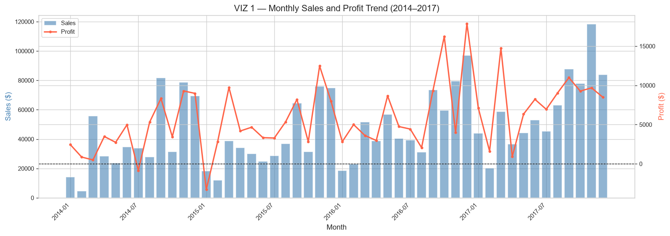
Observation: Sales and profit both trend upward from 2014 to 2017. Q4 months show consistent spikes, consistent with holiday retail seasonality. Some months show negative profit despite positive sales — likely driven by heavy seasonal discounting.

VIZ 2 — Sales and Profit by Category
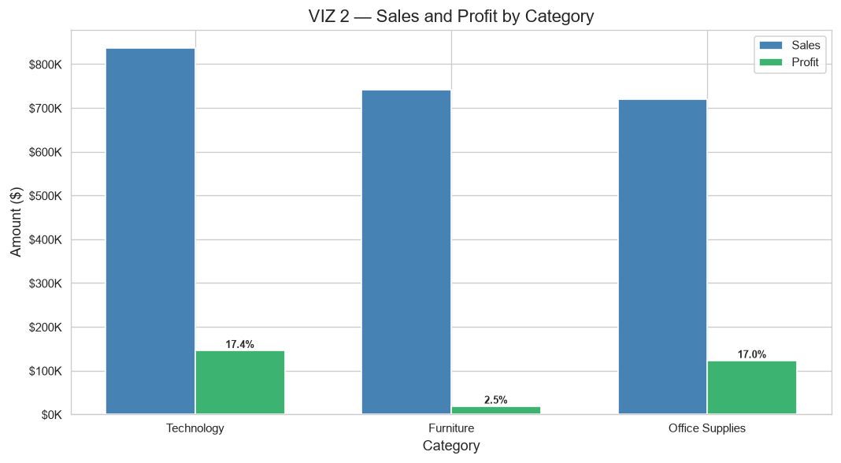
Observation: Technology leads in sales and profit margin. Furniture has the lowest margin relative to its sales volume. Office Supplies occupies the middle ground.

VIZ 3 — Sales and Profit by Region
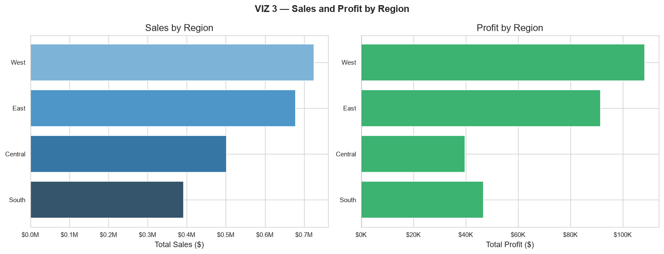
Observation: The West region leads in both sales and profit. The Central region shows disproportionately low profit relative to its sales volume.

VIZ 4 — Sub-Category Profitability
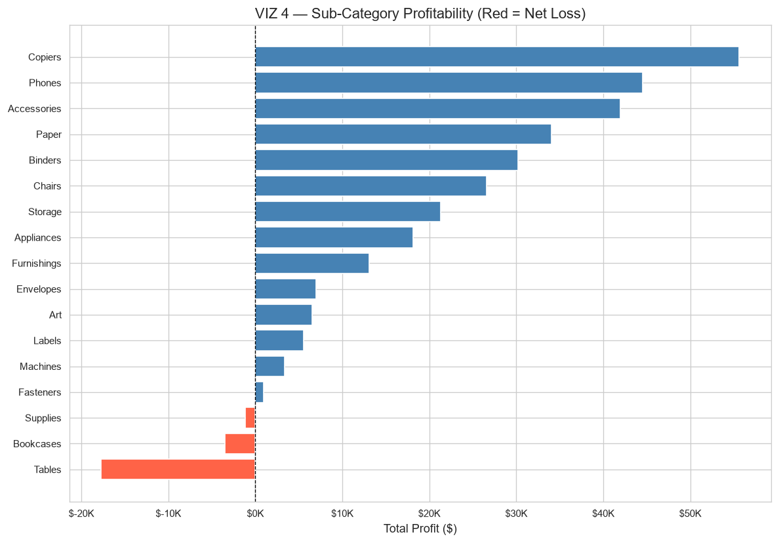
Observation: Copiers, Phones, and Accessories are the highest-profit sub-categories. Tables and Bookcases are net loss-making at aggregate level.

VIZ 5 — Discount vs Profit
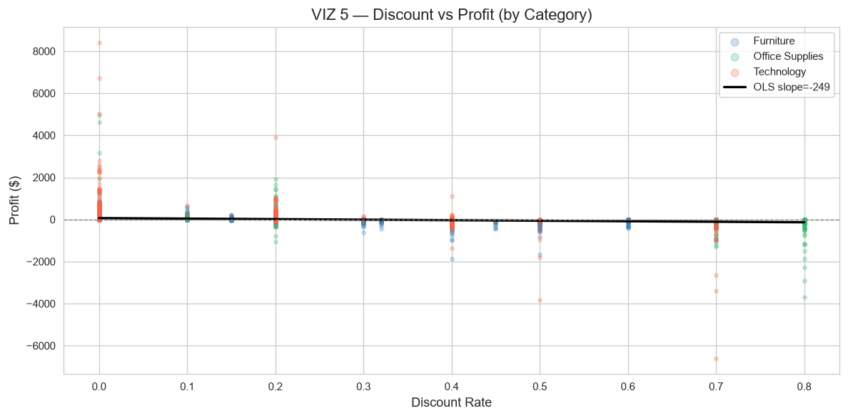
Observation: Clear negative linear association between discount rate and profit. Pearson r = -0.219. Orders with discount >= 40% are predominantly loss-making. Note: this is an association, not proof of causation.

VIZ 6 — Customer Segment Performance
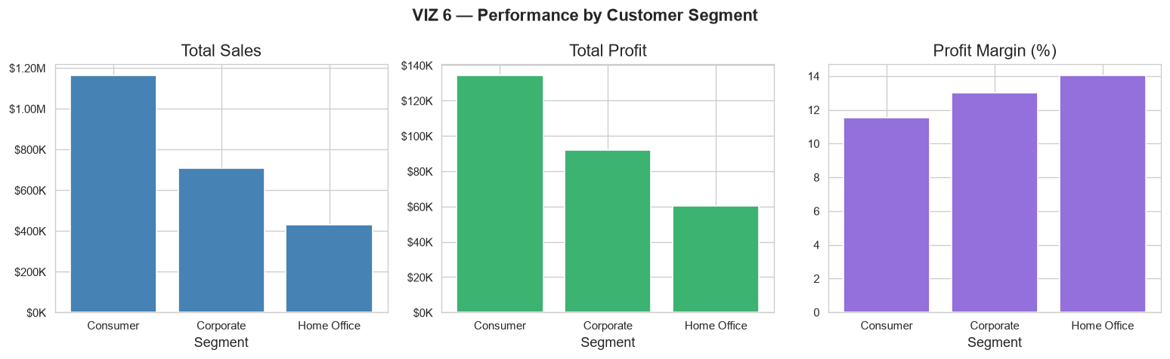
Observation: Consumer is the largest segment by volume. Home Office achieves the highest profit margin.

VIZ 7 — State-Level Profitability
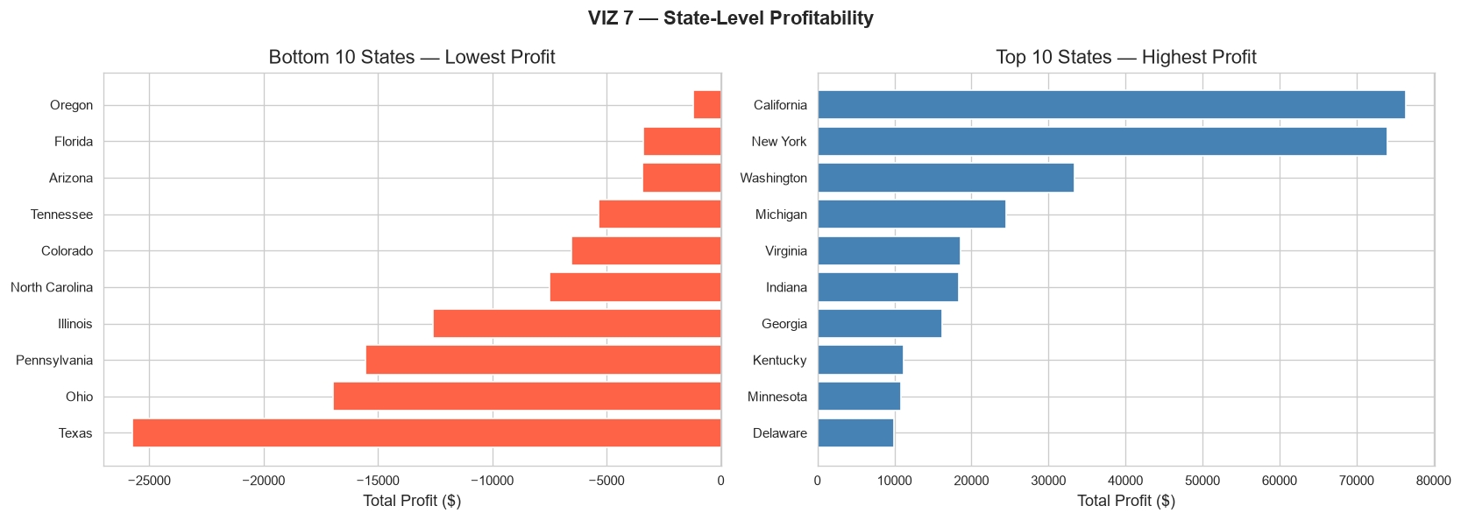
Observation: California and New York are the highest-profit states. Texas, Ohio, and Pennsylvania show significant aggregate losses.

11. Machine Learning Methodology
Objective: Binary classification — predict whether an order line will generate a loss.

11.1 Target Variable
Loss_Flag = 1 when Profit < 0 (loss-making)
Loss_Flag = 0 when Profit >= 0 (profitable)
Class distribution: No Loss (0) = 8,123 | Loss (1) = 1,871

11.2 Feature Engineering
Feature | Derivation | Rationale
Shipping_Duration | Ship Date − Order Date (days) | Proxy for logistics cost
Order_Year | Year of order | Temporal trend
Order_Month | Month of order | Seasonality
Order_Quarter | Quarter of order | Seasonality
Order_DayOfWeek | Day of week (0=Mon) | Order timing pattern

11.3 Leakage Prevention
Column/Feature | Decision | Reason
Profit | EXCLUDED | Loss_Flag is directly derived from Profit
Row ID / Order ID / Customer ID / Product ID | EXCLUDED | High-cardinality identifiers
Customer Name / Product Name | EXCLUDED | Free-text; unsafe representation
Country | EXCLUDED | Zero variance (all United States)
Postal Code / City | EXCLUDED | High cardinality; covered by State+Region
Sales | INCLUDED | Revenue is not a direct derivation of Profit
Discount, Quantity, Ship Mode… | INCLUDED | All available at order entry; no leakage

11.4 Model Training
Split: 80% training / 20% test, stratified by Loss_Flag.
Preprocessing: StandardScaler for numeric features; OneHotEncoder for categoricals.
Models evaluated: Logistic Regression (baseline) and Random Forest (200 trees).
Class weighting: class_weight='balanced' applied to handle class imbalance.

12. Model Evaluation Metrics
Model | Accuracy | Precision | Recall | ROC-AUC
Logistic Regression | 0.9195 | 0.7109 | 0.9599 | 0.9853
Random Forest | 0.9335 | 0.8051 | 0.8503 | 0.9832
Selected best model: Logistic Regression (ROC-AUC = 0.9853)

12.1 Confusion Matrix
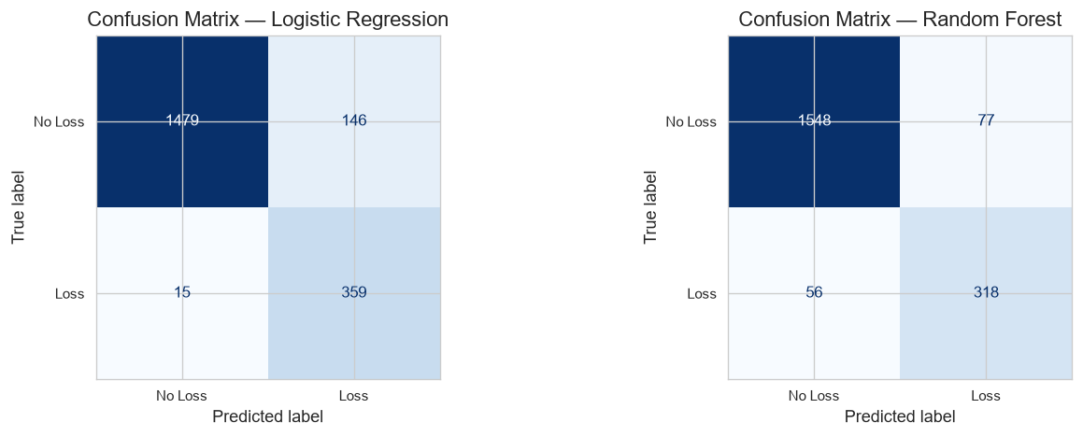

12.2 ROC-AUC Curve
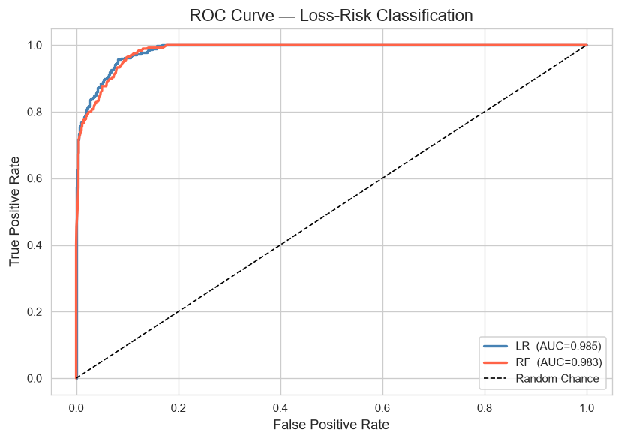

12.3 Business Interpretation of Confusion Matrix
Outcome | Definition | Business Impact
True Positive (TP) | Model flags loss; outcome is a loss | Correctly caught — enables proactive intervention
True Negative (TN) | Model clears order; outcome is profitable | Correctly approved — no unnecessary review effort
False Positive (FP) | Model flags loss; order is actually profitable | Wasted review effort on a healthy order (cost: analyst time)
False Negative (FN) | Model clears order; order generates a loss | Missed loss — real financial damage (highest business cost)
In retail loss prevention, False Negatives are more costly than False Positives. A missed loss causes real financial damage, while an unnecessary review only costs analyst time. Recall should therefore be weighted more heavily than Precision when selecting the operating threshold.

13. Prescriptive Analytics

REC 1 — Discount Cap Policy
Discount bands with >50% loss rate: ['21–30%', '31–40%', '41–50%', '>50%']. Action: Implement a hard cap or require senior-manager approval for any discount exceeding 30%. The data shows loss rate rises sharply above this threshold.

REC 2 — Sub-Category Pricing Review
Net loss-making sub-categories: ['Bookcases', 'Supplies', 'Tables']. Action: Conduct full cost-plus pricing review. Evaluate supplier costs, shipping weight, and return rates.

REC 3 — Regional Audit: Central
The Central region has the highest loss rate (31.9%). Action: Assign a regional sales manager to audit discount approvals and product mix.

REC 4 — Real-Time Loss-Risk Scoring
Deploy the trained Logistic Regression (ROC-AUC = 0.9853) as an order-entry risk scorer. Flag any order line with predicted loss probability > 0.50 for review before processing. Prioritise top 10% highest-risk lines daily.

REC 5 — Furniture/Tables Strategy
Tables is a net loss-making sub-category. Evaluate re-pricing, reducing max discounts on Furniture, or bundling with higher-margin accessories to protect category margin.

14. Limitations
- Dataset covers 2014–2017 only; insights may not reflect current market dynamics.
- Profit column does not include all overhead or logistics costs.
- ML model operates at line-item level; order-level aggregation not modelled.
- No external data (competitor pricing, economic indicators) available for enrichment.

15. Future Scope
- Add SHAP values for ML explainability.
- Build customer lifetime value (CLV) model.
- Incorporate time-series forecasting (Prophet / ARIMA).
- Implement XGBoost/LightGBM with hyperparameter tuning.
- Add geographic choropleth map visualisation.
- Develop a product recommendation engine using co-purchase patterns.

16. Conclusion
This project successfully applied the 4-Tier Analytics Ladder to the Superstore dataset, processing 9,994 clean records across 21 columns. Key findings include: an overall profit margin of 12.5%, 18.7% loss-making line items, a strong negative association between discount rate and profit (r = -0.219), and the identification of net loss-making sub-categories (Tables, Bookcases). The best-performing ML model (Logistic Regression) achieved ROC-AUC = 0.9853 on the held-out test set, demonstrating viable predictive power for operational loss-risk scoring. Five concrete, evidence-based prescriptive recommendations were formulated to guide discount policy, product pricing, regional management, and real-time risk scoring.

17. References / Dataset Source
Dataset: Superstore.csv.csv (Superstore sample retail dataset).
Widely attributed to Tableau sample data collection.
Exact original source URL: [placeholder — verify from your course materials or data source].

